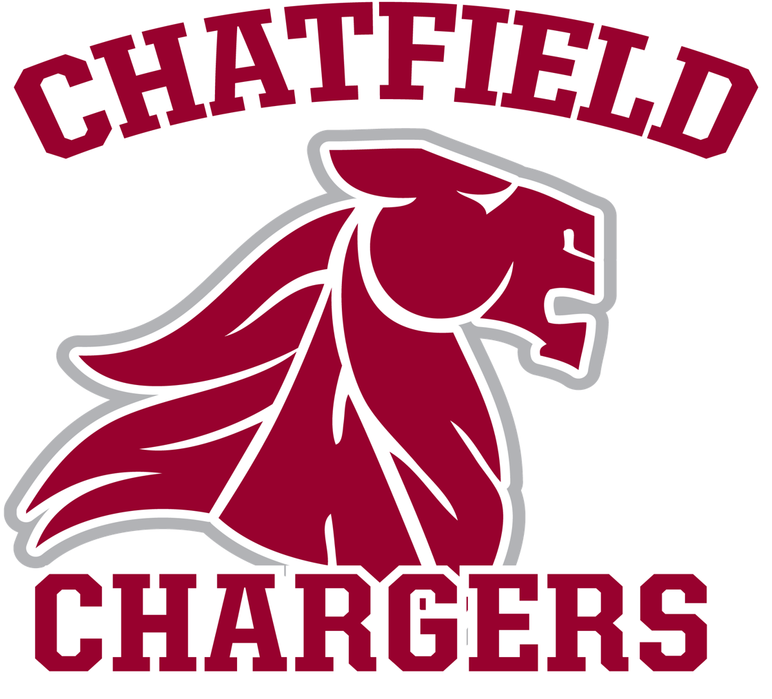  BASEBALL: Strength & Conditioning  (6 week program)  Program Goals: Develop and maintain strength, speed, condition, and power. Decrease injury and increase durability. Enhance performance. Compete.  NAME:_________________________________  Compiled by Andrew Mangold (2013-2017) with credit to Chris Joyner of the Toronto Blue Jays, Dr. Josh Heenan, Virginia Tech Football, CCSU Baseball and Snead State Community College Baseball. | Goal:  Date of Completion:  Goal:  Date of Completion:  Goal:  Date of Completion:  Goal:  Date of Completion:  Goal:  Date of Completion:  Goal:  Date of Completion:  Goal:  Date of Completion:  Goal:  Date of Completion:  Goal:  Date of Completion:  Goal:  Date of Completion:  Goal:  Date of Completion:  Goal:  Date of Completion:  Goal:  Date of Completion:  Goal:  Date of Completion:

Strength and Conditioning Program Philosophy
Program is designed to…
- Be as difficult as the athlete makes it.
- Reveal those who are not committed to the program.
- Eliminate weaknesses and create dominant strengths.
- Maximize athleticism.
DO’s
- Push yourself
- Be accountable
- Commit to your goals
- Learn and incorporate new things
- Record everything
- Develop physical/mental toughness
- Extra work
- Take pride in what you do
- Earn your spot
- COMPETE
DON’Ts
- Lift with a hat on!
- Act as an individual
- Accept mediocre results
- Believe there is an “off”season
- Forget you are always being watched
- Lose focus
- Be discouraged
- QUIT
Questions to ask yourself:
Am I waiting for it to happen or am I making it happen?
How disciplined am I?
Why is this important to me?
Do I love this?
If today was my last day at Chatfield, what is my legacy?

NO Long Distance Running
Why?
- Immune/Endocrine imbalances (avoid hormone “dumps”)
- Mobility loss (needless anatomical movement pattern)
- Speed loss (maximal effort not equating to maximal speed)
- Strength and Power Reductions (marathon runners don’t throw 90+ mph)
- Inappropriate Intensities (heart rate)
- Lack of coach attention (increase in injury risk)
- Super Boring (seen as punishment)

Exercises to Avoid
- Upright rows (replace with DB rows)
- Supermans (replace with Dead Bugs)
- Dips (replace with Push Ups)
- Barbell Bench Press (replace with DB Bench w/neutral grip)
- Overhead Lifts (Replace with Lateral push exercises)
- Back Squat (Replace with Various Lunges)

Note on Band Exercises/Arm Strength
Band exercises are not provided in this program. This is due to the common overuse of band exercises in place of proper stretching and proper strength training. Reminder: the fastest, safest, and most proven way to create arm strength is to throw a baseball. Throw often, throw long, throw hard, throw smart.

The 90 MPH Formula
Momentum: Height (inches) X 2.5 = Minimum BW (with Ideal Body Composition)
Force: Deadlift 1RM of 400lbs
Stability: Barbell Reverse Lunge w/BW on Barbell for 10 reps/side
Transfer: Chin-up 1RM of 250 lbs. (BW + added weight)
Power: Throw 300+ foot long toss

Foot Quickness Exercises
Overall athleticism is the greatest need for Chatfield Baseball. Demonstration of elite athleticism will result in Varsity playing time. An obvious and trainable skill for this program is footspeed. Footspeed translates into extra outs (offensively or defensively), extra runs, and extra wins; at all levels. Footspeed must be trained for all players; not just those with above average speed. There is a minimum athletic expectation in this program and at the next level.

JUMP ROPE
**pick 4 exercises to do 3 times a week for 30 seconds each**
- Two feet
- One foot
- Run in place
- Two on right, two on left
- Shuffle (boxer’s technique)
- Four square (jump with two feet in square pattern)
- Lateral (use line on ground or partners)
- Double unders
- Speed rope (as many rotations as possible in time frame)
- Hop forward

SPEED LADDER
**pick 6 exercises to do 3 times a week for 30 seconds each**
- One foot in each rung
- One foot in every other rung
- Two feet in each
- Three steps in each
- Sprint into one in every other rung (back up 10 yards and sprint into ladder)
- Lateral (each side)
- Ickey Shuffle
- Backward Ickey Shuffle
- Slalom jump
- Backward slalom jump

Conditioning Diagrams
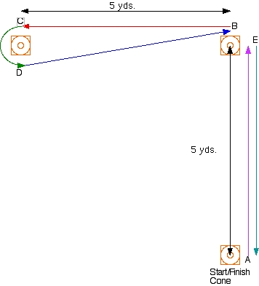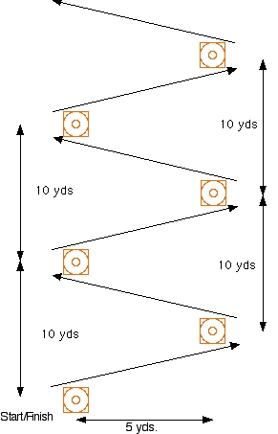
L- drill
Sprint and Cut

Pro Agility
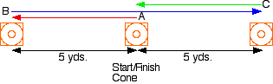

Daily Warm-Up
- Running High Knees (20 yds)
- Running Butt Kicks (20 yds)
- Walking Straight Leg Kicks (20 yds)
- Side Shuffle (20 yds)
- Carioca w/high knee drive (20 yds)
- Walking knee tuck & quad stretch (10 yds)
- Lunge w/ Slow Twist (10 yds)
- Side Lunge and Pivot (10 yds)
- Backward Lunge w/hands overhead (10 yds)
- Inchworms (10 yds)
- Backwards Bear Crawl (10 yds)
- Active Shoulder and Oblique Warm-Up (Captain led)

Daily Metabolic Work
Captains choose 5 exercises to include for 5-10 straight minutes of high intensity interval work (i.e. :30secs of each exercise, going through twice)
- Jumping Jacks
- Burpees
- Seal Jacks (clap in front)
- Mountain Climbers
- Bottoms Up (lay on back, tuck knees to chest, extend legs directly above, elevate pelvis, pause, return to flat ground position)
- Rope Slams
- Rope Slam circuit: reverse lunge, lateral lunge, front/backwalk, shuffle
- Bear Crawl
- Lateral Push-Up Walk
- Tuck Jumps
- 90 degree hops (hop quickly in a “L”; one jump at each point)
- Ski jumpers
Post Workout Stretching
Post workout stretching should consist of foam rolling, static stretching, active recovery techniques, and mobility exercises. These are not provided in this program due to the endless exercises available and variability of athletes’ needs.
WEEK 1: “Success is not final, failure is not fatal: it is the courage to continue that counts”
Day 1:
Abs Leg Raises: 30-45 secs, Flutter kicks: 30-45 secs, Twisting Sit Ups: 30-45 secs
Power Barbell Glute Bridge: warm up (1 X 5), 4 X 3 (increasing weight)
Lower Body Strength Reverse BB Lunge: warm up (1 X 8), 3 X 7 (increasing weight)
Upper Body Strength DB Bench (neutral grip): warm up (1 X 8), 3 X 8
Secondary Lifts Push Ups (weighted): 3 X 5, Bent over BB rows: 3 X 10, Pull Ups (weighted if needed) 3 X 8, Glute Ham Raise 2 X 10, Intense Partner Stretch

Day 2:
Abs V-ups: 2 X 20 (reps), Crunchy frogs: 2 x 30 secs, Plank w/elbow to knee: 1 minutes
Power Trap Bar Deadlift: warm up (1 X 3), 4 X 3
Lower Body Strength DB Walking Lunges: 4 X 20 yds; RDLs 3 X 6
Upper Body Strength Squeeze Press: 4 X 5
Secondary Lifts Cable Pulldowns: 3 X 8; Lat Pulldowns: 3 X 8, Reverse Grip Triceps Pushdown: 3 X 10; BB Behind the Back Forearm Curls: 3 X 8
Day 3:
Abs Captain choice
Power Rotational/Squat Med Ball Throws: 5 X 5
Lower Body Strength DB/ KB Goblet Squat: warm up (1 X 5), 4 X 5 (increasing weight)
Upper Body Strength DB Decline Bench Press: warm up (1 X 8), 3 X 6
Secondary Lifts Manual Resistance Triceps: 2 X 10; DB Bent Rows: 3 X 8; Reverse Hyperextension: 2 X 20, BB Behind the Back Forearm Curls: 1 X 6, Bar Hang: 1 minute
Conditioning:
Day 1: 10 yd steal (X5), 20 yd sprint (X5), 60 yd sprint (X5)
Day 2: Sprint & Cut (X5), Pro-agility (X5), L-drill (X5)
Day 3: Game (Captain choice) OR Timed Hard 90s (X3), 1st to 3rd (X3), Inside the park HR (X1)

WEEK 2: “Never bend your head. Always hold it high. Look the world straight in the eye.”
Day 1:
Abs Leg Raises: 30- 45 secs; Flutter kicks: 30-45 secs; Twisting Sit Ups: 30-45 secs
Power Barbell Glute Bridge: warm up (1 X 3), 5 X 3 (increasing weight)
Lower Body Strength BB Reverse Lunges: warm up (1 X 5), 4 X 6 (increasing weight)
Upper Body Strength DB Bench Press: warm up (1 X 8), 5 X 6 (increasing weight)
Secondary Lifts DB Squeeze Press: 3 X 5; Weighted Pull Ups: 3 X 8; Glute Ham Raise: 2 X 10; BTB BB Forearm Curls: 3 X 8; Bar Hang: 1 minute
Day 2:
Abs Leg throws: 2 X 25; Plank w/elbow to knee: 1 minute
Power Deadlift Trap Bar: warm up (1 X 3), 4 X 3
Lower Body Strength DB Walking Lunges: 4 X 20 yds; RDLs: 3 X 6
Upper Body Strength Plyo Pushups: 3 X 6; Med-ball Pushups: 3 X 8, Partner Resistance Pushups: 2 X 10
Secondary Lifts Cable Pulldown: 3 X 8, Lat Pulldown: 3 X 8, Triceps (Captain Choice)
Day 3:
Abs Captain choice
Power Med-Ball Rotational Throws: 3 X 8; Med-Ball Slams: 3 X 5
Lower Body Strength Goblet Squat: warm up (1 X 5), 2 X 5, 2 X 3 (increasing throughout)
Upper Body Strength Squeeze Press: 4 X 5
Secondary Lifts DB Decline Bench Press: 3 X 6; Barbell Bent Over Row: 3 X 10; Reverse Hyperextension: 2 X 20; BTB BB Forearm Curls: 1 X 10; Bar Hang: 1 minute
Conditioning:
Day 1: 10 yd steal (X5), 20 yd sprint (X5), 60 yd sprint (X5)
Day 2: Sprint & Cut (X5), Pro-agility (X5), L-drill (X5)
Day 3: Game (Captain choice) OR Timed Hard 90s (X3), 1st to 3rd (X3), Inside the park HR (X1)

WEEK 3: “Believe you can and you’re halfway there.”
Day 1:
Abs Leg Raises: 30–45 seconds, Flutter kicks: 30-45 secs, Twisting Sit Ups: 30-45 secs, Dead Bug: 1 X 5 (each side)
Power Barbell Glute Bridge: Warm up (1 X 3), 1 X 3, 3 X 1, near 1RM (increasing weight throughout)
Lower Body Strength BB Reverse Lunge: Warm up (1 X 5), 4 X 5 (increasing weight)
Upper Body Strength DB Bench Press: Warm up (1 X 8), 5 X 6 (increasing throughout)
Secondary Lifts MR Triceps: 3 X Failure, Chin ups: 3 X 10, Glute Ham Raise: 1 X 10, Reverse Hyperextension: 1 X 20, Bar Hang: 1 minute
Day 2:
Abs Leg Throws: 1 X 30, 1 X 20; Plank: 90 seconds
Power Deadlift Trap Bar: warm up (1 X 3), 4 X 3
Lower Body Strength DB Walking Lunges: 4 X 20 yds; RDLs: 3 X 6
Upper Body Strength Decline DB Bench Press (hold at bottom for 3 secs): 4 X 6
Secondary Lifts Cable Pulldown: 3 X 8; Lat. Pulldown: 3 X 8; Big Arms: 3 sets, BB Shrugs: 1 X 10, 1 X 6
Day 3:
Abs Captain Choice
Power Med Ball Rotational Throws: 4 X 3
Lower Body Strength Goblet Squat: 3 X 5, 1 X 3, 1 X 2 (increasing weight throughout)
Upper Body Strength Squeeze Press: 4 X 5
Secondary Lifts DB Incline Bench (lightweight w/scapular contraction): 3 X 6; Barbell Bent Rows (very heavy): 3 X 8; Glute Ham Raise: 1 X 10; Reverse Hyperextension: 1 X 20; BB shrugs: 1 X 10, 1 X 6; Bar Hang: 1 minute
Conditioning:
Day 1: 10 yd steal (X5), 20 yd sprint (X5), 60 yd sprint (X5)
Day 2: Sprint & Cut (X5), Pro-agility (X5), L-drill (X5)
Day 3: Game (Captain choice) OR Timed Hard 90s (X3), 1st to 3rd (X3), Inside the park HR (X1)
WEEK 4: “Life is like riding a bicycle. To keep your balance, you must keep moving.”
Day 1:
Abs Plank: 90 secs, Crunches: 60 seconds
Power Clean Pulls: Warm up (1 X 3), 4 X 3 (increasing weight)
Lower Body Strength Split Squat: Warm up (1 X 5), 4 X 5 (increasing weight)
Upper Body Strength DB Bench Press: Warm up (1 X 8), 5 X 5 (increasing weight)
Secondary Lifts Reverse Grip Triceps Pushdown: 1 X 12, 1 X 10, 1 X 8; One Arm DB Row: 3 X 8; Leg Curls 4 X 10; BTB BB Forearm Curls: 1 X 10
Day 2:
Abs Leg Throws: 2 X 25
Power Deadlift (heavy): warm up (1 X 3), 4 X 3
Lower Body Strength Walking DB Lunges: 3 X 20 yds
Upper Body Strength DB Floor Press: 5 X 5
Secondary Lifts Cinder Block Pushups: 3 X 10, Buddy Curls w/ Curl Bar: 1 X 10, 9, 8, 7,6, 5, 4, 3, 2, 1; BB Shrugs: 1 X 6
Day 3:
Abs Captain Choice
Power Rotational Med Throws: 4 X 3
Lower Body Strength Split Squat: warm up (1 X 5), 4 X 5
Upper Body Strength Decline DB Bench Press: 5 X 5
Secondary Lifts Cable Pulldown (light, slow & controlled): 1 X 35; Pull ups: 3 X 10; Glute Ham Raise: 1 X 10; Reverse Hyperextension: 1 X 20; Jump Rope: 1 minute
Conditioning:
Day 1: 10 yd steal (X5), 20 yd sprint (X5), 60 yd sprint (X5)
Day 2: Sprint & Cut (X5), Pro-agility (X5), L-drill (X5)
Day 3: Game (Captain choice) OR Timed Hard 90s (X3), 1st to 3rd (X3), Inside the park HR (X1)
Goal Check:
How many goals have you reached? What goals remain? What can you do to reach your goals? Thinking ahead to the next season, what are some new goals? Is there anything preventing you from reaching your goals? Do you have someone to keep you accountable? Are you a leader or a follower? WHY?
WEEK 5: “Nothing is impossible. The word itself says ‘I’m possible!’”
Day 1:
Abs Partner Resistance Abs: 2 X 60 seconds
Power BB Step Ups: warm up (1 X 3 each side), 5 X 3 each side (increasing weight)
Lower Body Strength Split Squat: warm up (1 X 5), 4 X 5 (increasing weight)
Upper Body Strength DB Bench Press: warm up (1 X 8), 4 X 5 (increasing weight)
Secondary Lifts Reverse Grip Triceps Pushdown: 3 X 10; One Arm DB Row: 3 X 8; Leg Curls: 3 X 10; BTB BB Forearm Curls: 1 X 10
Day 2:
Abs Weighted Planks: 2 X 60 secs
Power Trap Bar Deadlift: Warm up (1 X 3), 4 X 3
Lower Body Strength DB Step ups: 3 X 20
Upper Body Strength DB Floor Press: 5 X 5
Secondary Lifts Cinder Block Pushups: 3 X 10; MR Triceps: 3 X Failure; Buddy Curls w/ curl bar: 1 X 10,9,8,7,6,5,4,3,2,1; DB Shrugs: 2 X 6; Bar Hang: 1 minute
Day 3:
Abs Captain choice
Power Tire Flips: 4 X 3 (heavy), 3 X 8 (light)
Lower Body Strength Calf Raise: warm up (1 X 5), 4 X 5; Box Jumps (speed!): 4 X 12, 3 X 8
Upper Body Strength Decline DB Bench Press: 5 X 3
Secondary Lifts Cable Pulldown: 3 X 15; Pullups: 3 X 10; Leg Curls 3 X 15
Conditioning:
Day 1: 10 yd steal (X5), 20 yd sprint (X5), 60 yd sprint (X5)
Day 2: Sprint & Cut (X5), Pro-agility (X5), L-drill (X5)
Day 3: Game (Captain choice) OR Timed Hard 90s (X3), 1st to 3rd (X3), Inside the park HR (X1)
Consistency Check:
Are you writing down your weights every lift? Are you giving consistent effort? Do you have quality technique? Are you consistently hydrated? Are you eating constantly? Are you using proper arm care routines? IF NOT, WHY NOT?
WEEK 6: “You get what you give.”
Day 1:
Abs Deadbug: 3 X 10, Leg Throws: 2 X 20
Power Med Ball Rotational Throws: 4 X 3
Lower Body Strength Goblet Squat: Warm up (1 X 5), 1 X 5, 3 X 3, 1RM (increasing weight)
Upper Body Strength DB Bench Press: warm up (1 X 8), 1 X 5, 1 X 3, 1 X 2, 1RM (increasing weight)
Secondary Lifts One Arm DB Row: 3 X 8; Cable Pulldown: 3 X 10; Leg Curls: 2 X 10; Forearm BTB BB Curls: 1 X 10
Day 2:
Abs Partner Leg Throws and Sit Ups: 2 X 30 for each exercise
Power Deadlift: Warm up (1 X 3), 3 X 3, 1RM
Lower Body Strength Walking DB Lunges: 3 X 20 yds; RDLs: 3 X 8
Upper Body Strength DB Floor Press: 5 X 5
Secondary Lifts Cinder Block Pushups: 3 X 10; Big Arms: 3 sets, Cable Row: 2 X 5, Bar Hang: 1 minute
Day 3:
Abs Captain choice
Power Barbell Glute Bridge: warm up (1 X 3), 3 X 3, 1RM (increasing weight)
Lower Body Strength BW Squat (speed): 5 X 10
Upper Body Strength Decline DB Bench Press: 5 X 5
Secondary Lifts Reverse Grip Triceps Pushdown: 3 X 15; Weighted Chin Ups: 3 X 10; Reverse Hyperextension: 2 X 20
Conditioning:
Day 1: 10 yd steal (X5), 20 yd sprint (X5), 60 yd sprint (X5)
Day 2: Sprint & Cut (X5), Pro-agility (X5), L-drill (X5)
Day 3: Game (Captain choice) OR Timed Hard 90s (X3), 1st to 3rd (X3), Inside the park HR (X1)
“There may be people that have more talent than you, but there is no excuse for anyone to work harder than you do.”
-Derek Jeter
Hydration
“Water is the most neglected nutrient in your diet but one of the most vital.”
- 5 % dehydration = 20 % loss of muscle function
- PREHYDRATE: Drink 24 oz. (or more) of water less than 30 minutes before lifting, practice, games, any physical activity
- HYDRATE: Drink 24 oz. (or more) of water during lifting, practice, games, any physical activity
- REHYDRATE: Drink 24 oz. (or more) of water/pound of sweat lost during activity
- If you wait until you are thirsty; you are too late!

Nutrition
This program offers the most basic advice on nutrition. Work with a coach/nutritionist to determine your overall diet, protein powders, supplements, vitamins, etc. The majority of your work will NOT matter if you do not eat properly. Chatfield Baseball expects you to be diligent about and dedicated to your diet. What goes in to your body drives what you get out of your body. Nutrition is more important than the weights you lift.
PROTEIN:
Excellent sources (high protein, low fat): roast turkey, baked chicken (white meat, no skin), baked fish, skim milk, lean baked ham, tuna (packed in water), yogurt (low or nonfat), dried beans and peas.
Acceptable sources (high protein, moderate fat): 85% lean ground beef, 85% lean ham, trimmed choice steak, trimmed pork chops, baked chicken strips, 2% milk, regular yogurt, dark meat chicken (no skin), peanut butter.
**Fat needs are dependent on the athlete body composition and overall metabolic needs.**
CARBOHYRDATES:
Excellent sources (lowest glycemic response, lowest fat = long lasting energy): Dried Beans and peas, squash, cucumbers, green beans, broccoli, spinach, mushrooms, nectarines, pears, plums, onions, eggplant.
Acceptable sources (moderate glycemic response, for active days, helpful immediately after exercise): Unsweetened cereal, pasta, whole grain breads, brown or wild rice, cornbread, tortillas, pita bread, potatoes (with skin), grapes, apples, bananas, corn, carrots
Exercise Descriptions
**Not all exercises are explained in the following; only exercises that are expected to be new to Chatfield Baseball athletes**
Big Arms: All of the following exercises should be completed continuously without dropping the barbell. Do not take breaks and only have your partner assist on the final phase.
- Begin with a barbell and added weight (no more than 85 lbs. total) and complete 10 power bicep curls (can use some legs but do not lean back).
- Remove added weight from barbell, and complete 10 bicep curls (no leg involvement).
- Complete 10 “halfway up” bicep curls (start with barbell resting along with waist with arms unbent; then only curl the barbell up to slightly less than 90° angle of forearm and upper arm).
- Complete 10 “halfway down” bicep curls (start with barbell at finishing position with barbell along clavicles, then lower the barbell to slightly less than 90° angle of forearm and upper arm; return barbell with curling motion).
- Hold barbell at 90° angle of forearm and upper arm for at least 30 seconds. This should be difficult and partner assistance is allowed.

Buddy Curls: With a partner, add sufficient weight to an EZ curl bar so that it can be curled at minimum 10 times but is still a challenge to both athletes. Do not put the bar down throughout the exercise.
- Complete 10 Bicep curls and then hand over bar for your partner to complete 10 reps as well. Your partner then returns the bar to you.
- Complete 9 Bicep curls and then hand over bar for your partner to complete 9 reps as well. Your partner then returns the bar to you.
- Complete 8 bicep curls….continue decreasing by one rep until you reach one rep for each partner.

Crunchy Frogs:
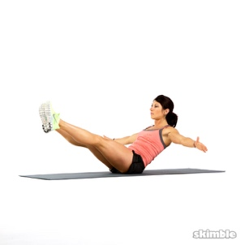

DB Floor Press: Use DBs heavier than normal DB Bench Press lifts. For example, if you normally use 45 lbs. DBs on DB Bench Press; try 60 lbs. DBs on DB Floor Press. This lift must have a vigilant and active spotter to prevent DBs from falling and causing shoulder injury and/or landing on the lifter’s face.
- Grab DBs with an overhand grip and lie flat on your back. Extend legs flat on ground. Extend elbows to a 90-degree position, triceps resting on floor, while holding dumbbells above your chest.
- Exhale and brace core while simultaneously extending dumbbells toward ceiling. Pause, and retract back to staring position.
- When done with set, have spotter remove the DBs from one hand at a time.
Dead Bugs: Designed to be part of a superset with your previous exercise.
- Lie face-up with your arms extended toward the ceiling, and knees bent 90 degrees, calves parallel to floor
- Keeping your shoulders down and feet flexed, engage your core and extend your right arm and left leg away from you
- Tap your heel to floor and return to center. Immediately repeat on the opposite side. Continue alternating sides
Barbell Glute Bridge: Begin with 135 lbs., develop form, go heavier.
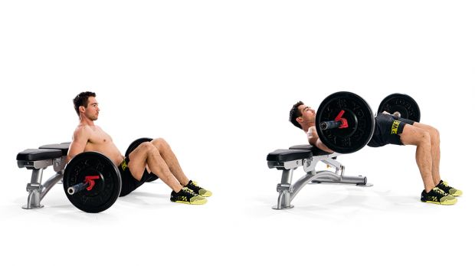
Position the center of the bar at your waist or slightly above, with a squat pad or towel or yoga mat between you and the barbell. Slowly lower, and then initiate the pressing phase by driving through your heels. Extend vertically at the hips at the top portion of the lift, making sure to fully extend glutes to bench level.

Glute Ham Raise:
Knees should be just behind the pad. Start from the bottom of the movement. Keep your back arched as you begin the movement by flexing the knees. Drive your toes into the foot plate. Keep your upper body straight, and continue until your body is upright. Return to the starting position, keeping your descent under control.
Goblet Squat:
Get lower than 90°; low enough for your glutes to touch your calves while keeping your heels on the ground.
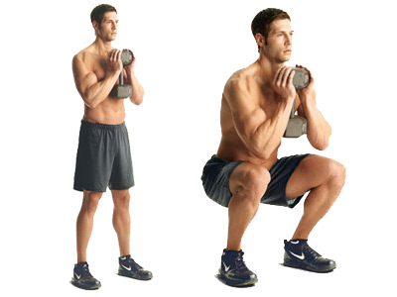

Manual Resistance Triceps Extension: Do not use a DB. Use a towel.
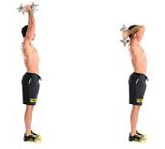
Hold the ends of a small towel in each hand and assume the position below on the right. Your partner will resist your extension by pulling down on the center of the towel. Keep movement smooth and under control. Resist on both the extension and flexion of the movement. It is important to not pull down further than the tops of the scapular muscles

Reverse Grip Triceps Pushdown:
- Facing the bar attachment, grab it with the palms facing up at shoulder width. Lower the bar by using your lats until your arms are fully extended by your sides. Elbows should be by your sides and your feet should be shoulder width apart. This is the starting position. Slowly elevate the bar attachment. Only the forearms should move and the elbows/upper arms should be stationary.
- Then begin to lower the cable bar back down to the original staring position while exhaling and contracting the triceps hard.

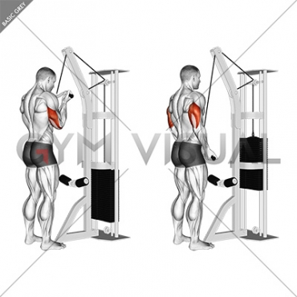

Squeeze Press:
- Step 1: Take the dumbbells in your hands and lay down on the bench
- Step 2: Place the dumbbells together side by side and lift them up over your chest
- Step 3: Lower them down together and touching each other and then push the dumbbells back up.

